Car Class Development:
I intend to have separate AI_Car and Player_Car classes that both inherit from an abstract Car class. This is so that they can both share the same physics, collision detection and rendering mechanism, while ensuring they have separate control mechanisms. I started off by coding a basic prototype of the Car class (with user controls) to test basic physics and updates.
Initially, I made it so that the user can hold ‘D’ to increment steering (causing the car to steer right) and can hold ‘A’ to decrement the steering angle (causing it to steer left). I decided to smoothly increment the variable rather than just rotating the sprite to emulate how a steering wheel turns.
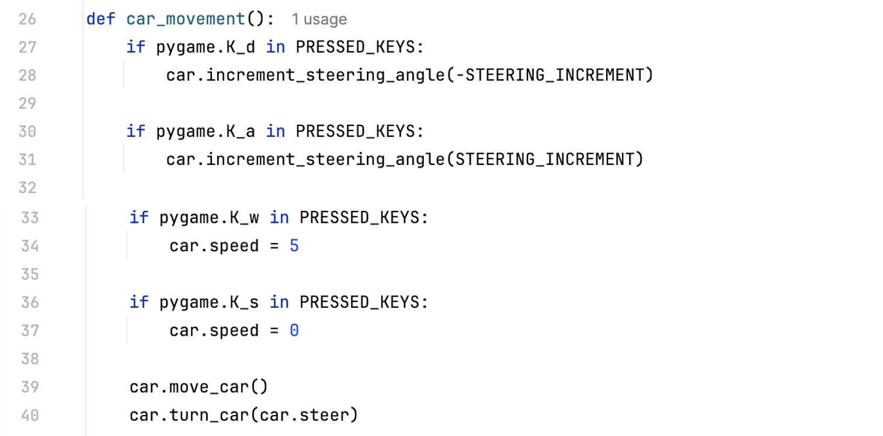
However, I was not happy with the way the steering felt slow. So, to solve this issue while still maintaining a similar modelling of a real-life steering wheel, I decided to make it so that the player can use a slider to control the steering. The steer variable is still incremented gradually by a factor of the maximum turning angle, but using a slider allows for both extreme as well as controlled changes in steering.
For the prototype, I decided to simplify the physics of movement by omitting the modelling of forces affecting the motion of the car. This means not modelling traction, rolling resistance, drag, understeer and oversteer (drifting). Instead, acceleration, velocity and displacement are all modelled in as vectors which increment and decay by arbitrary rates. This prototype does also have unrealistic steering mechanics since the car can rotate even when static. However, it works to test the RL model

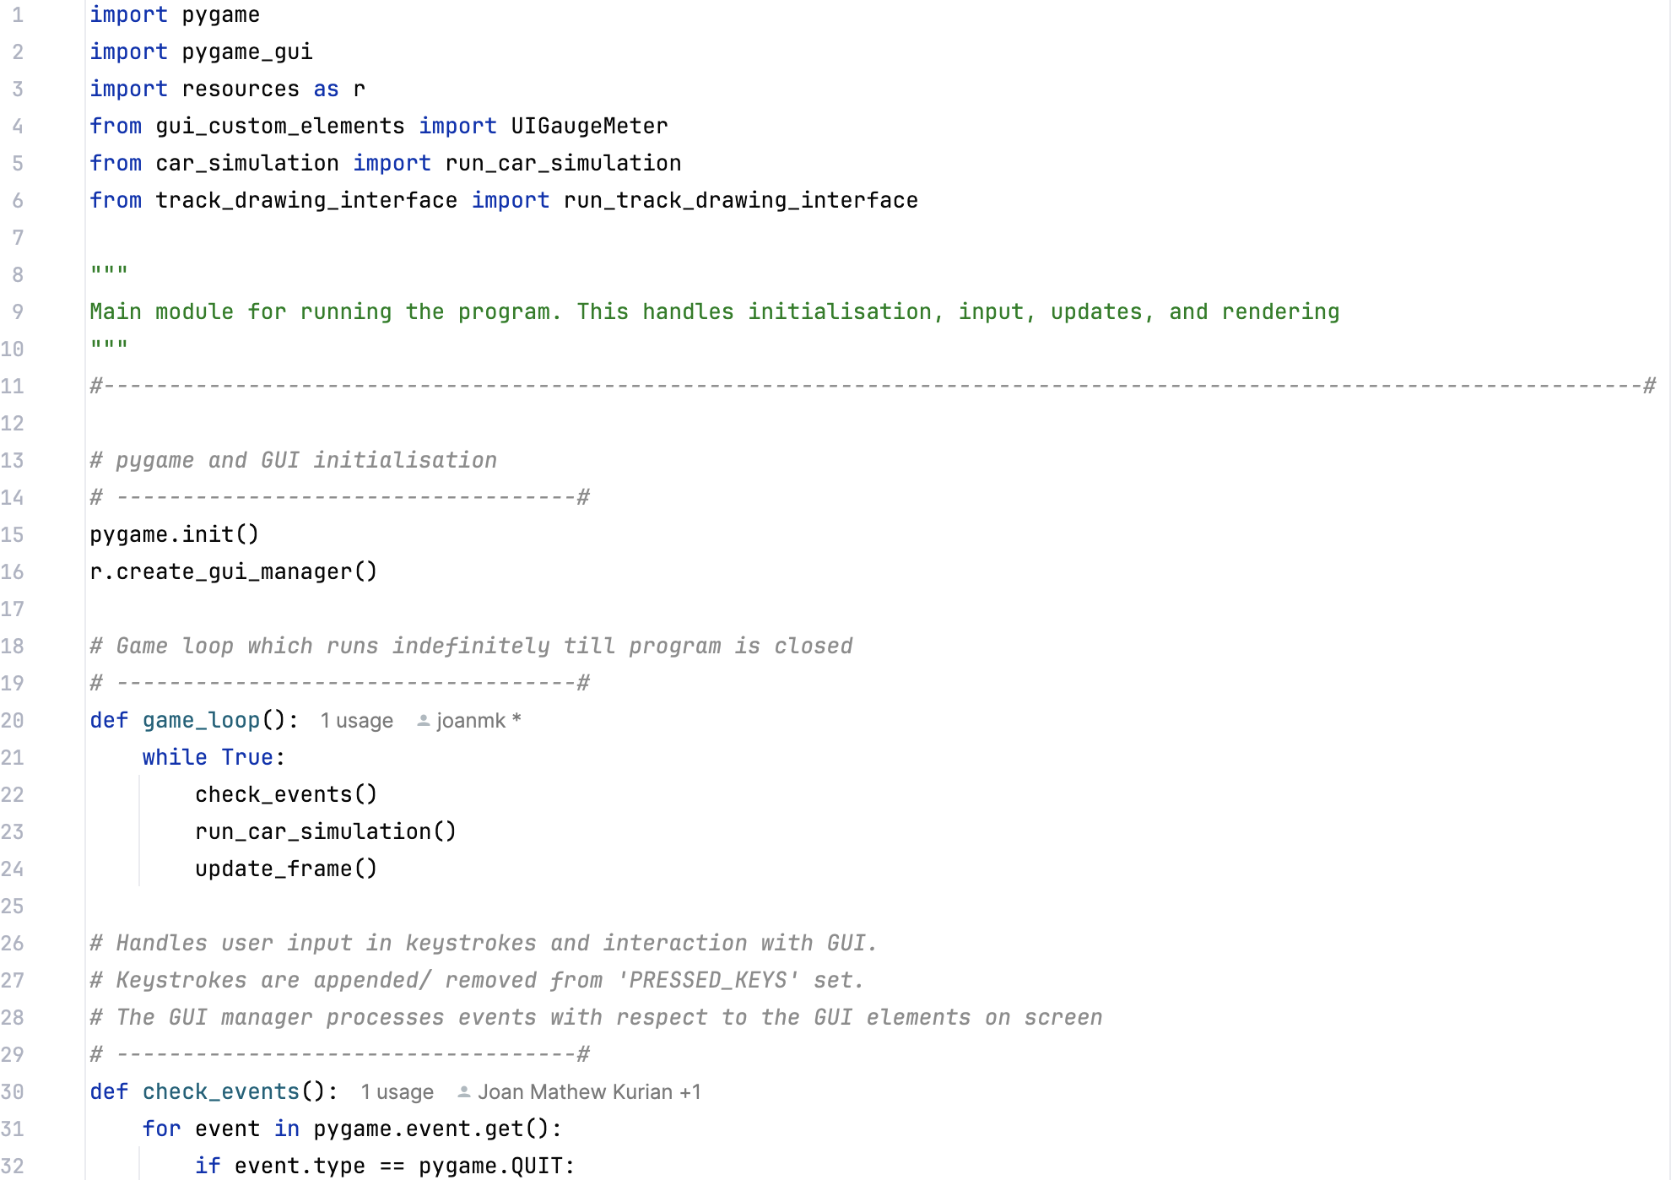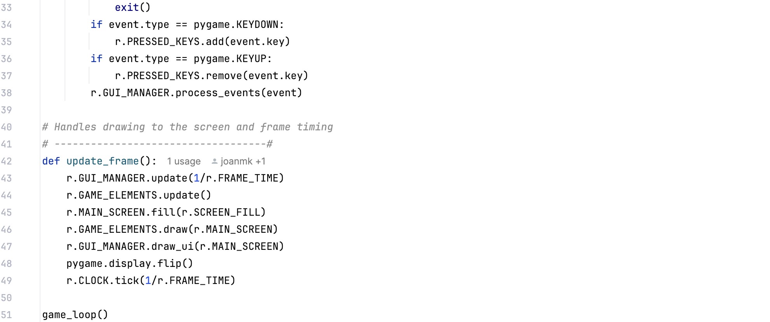
Car
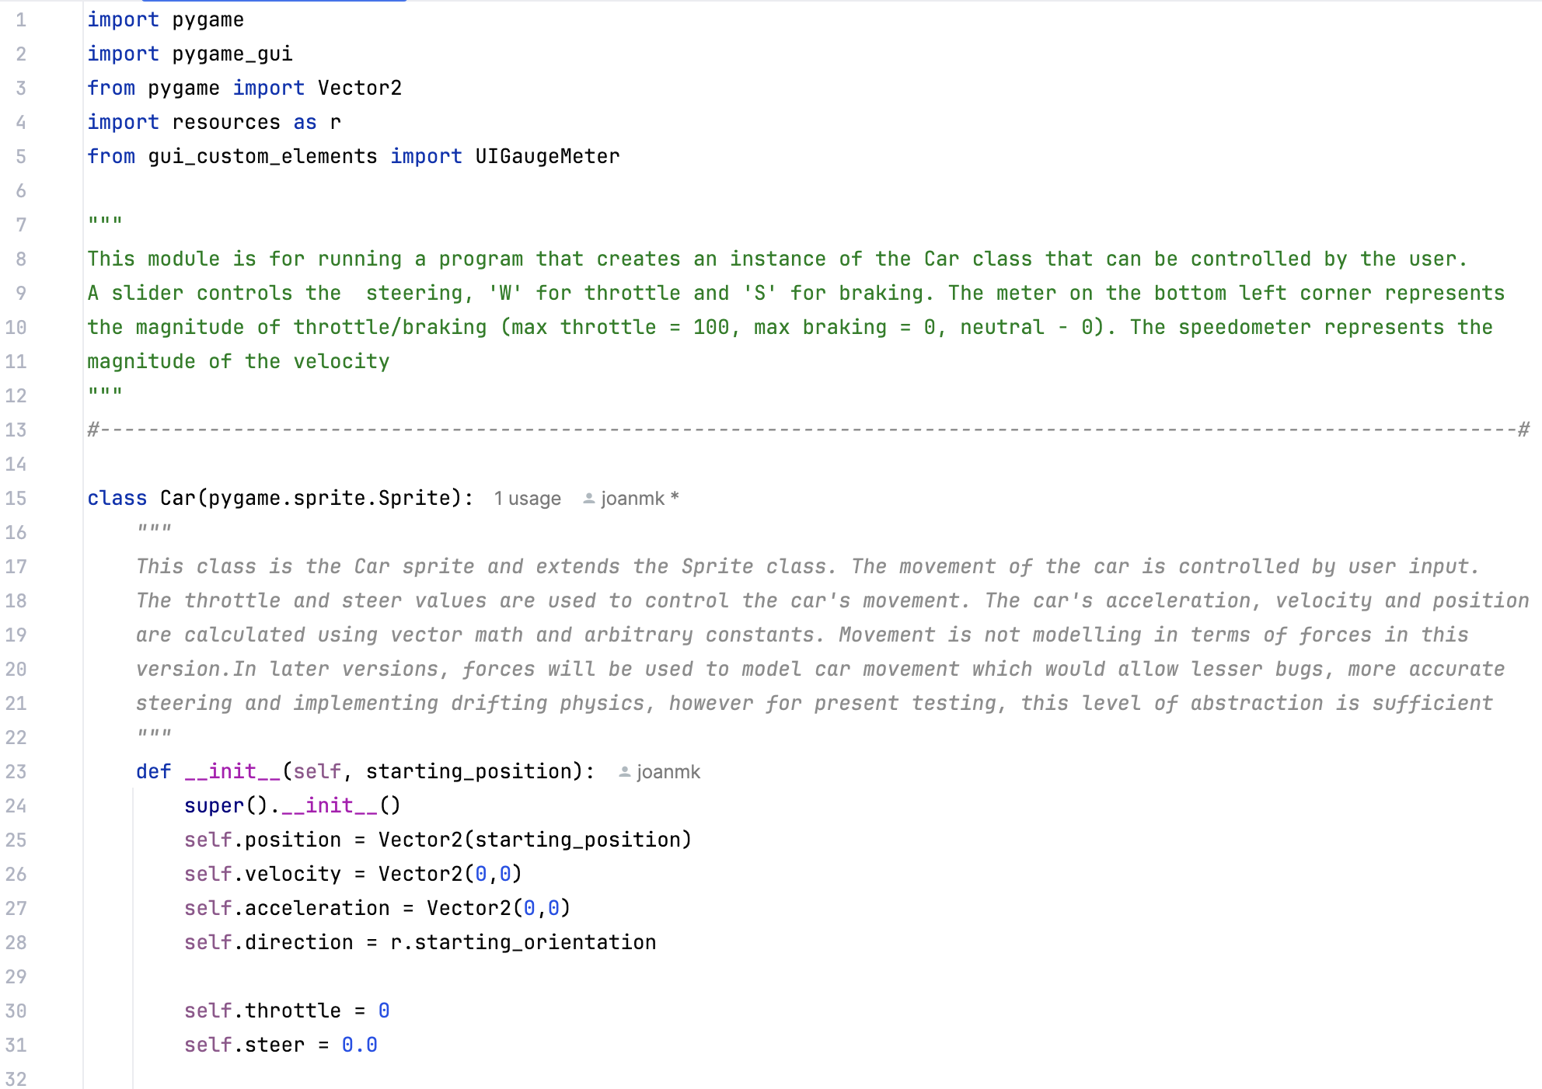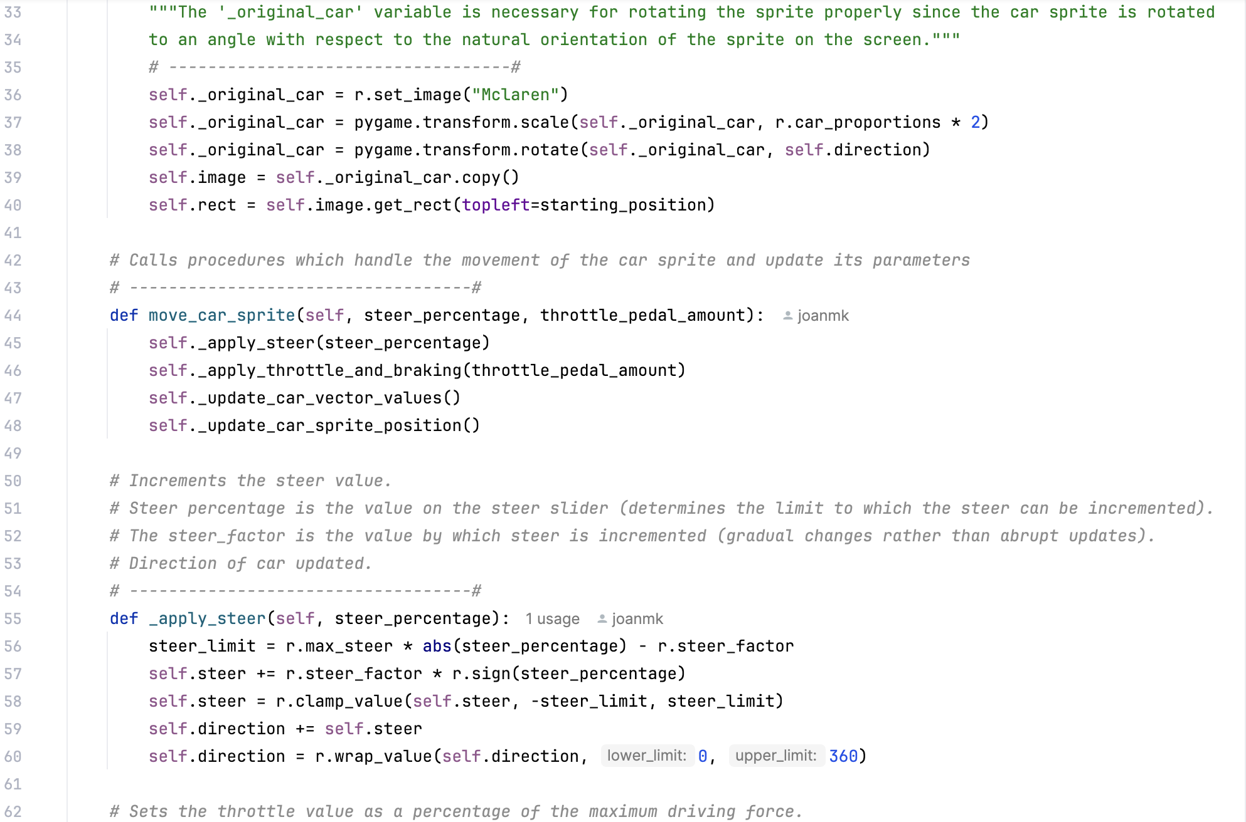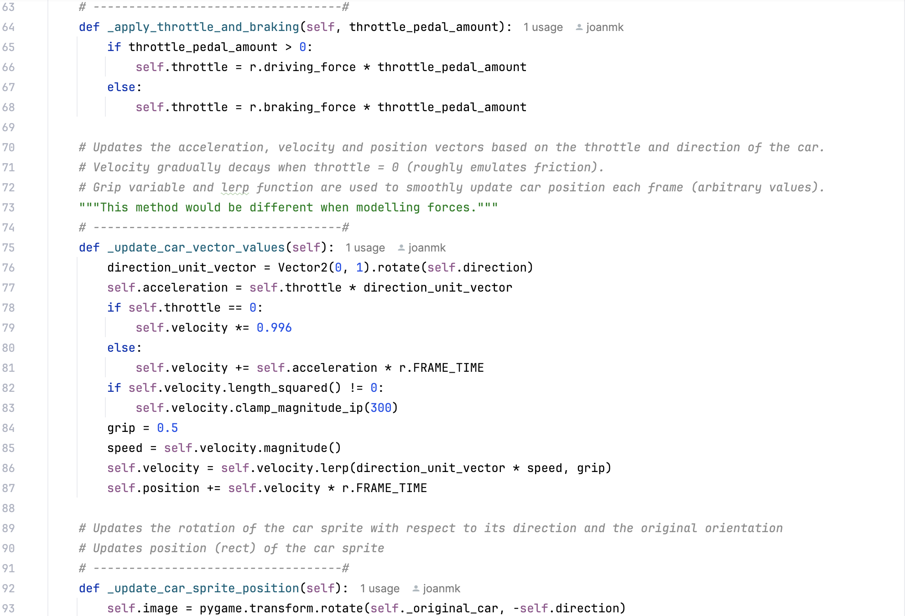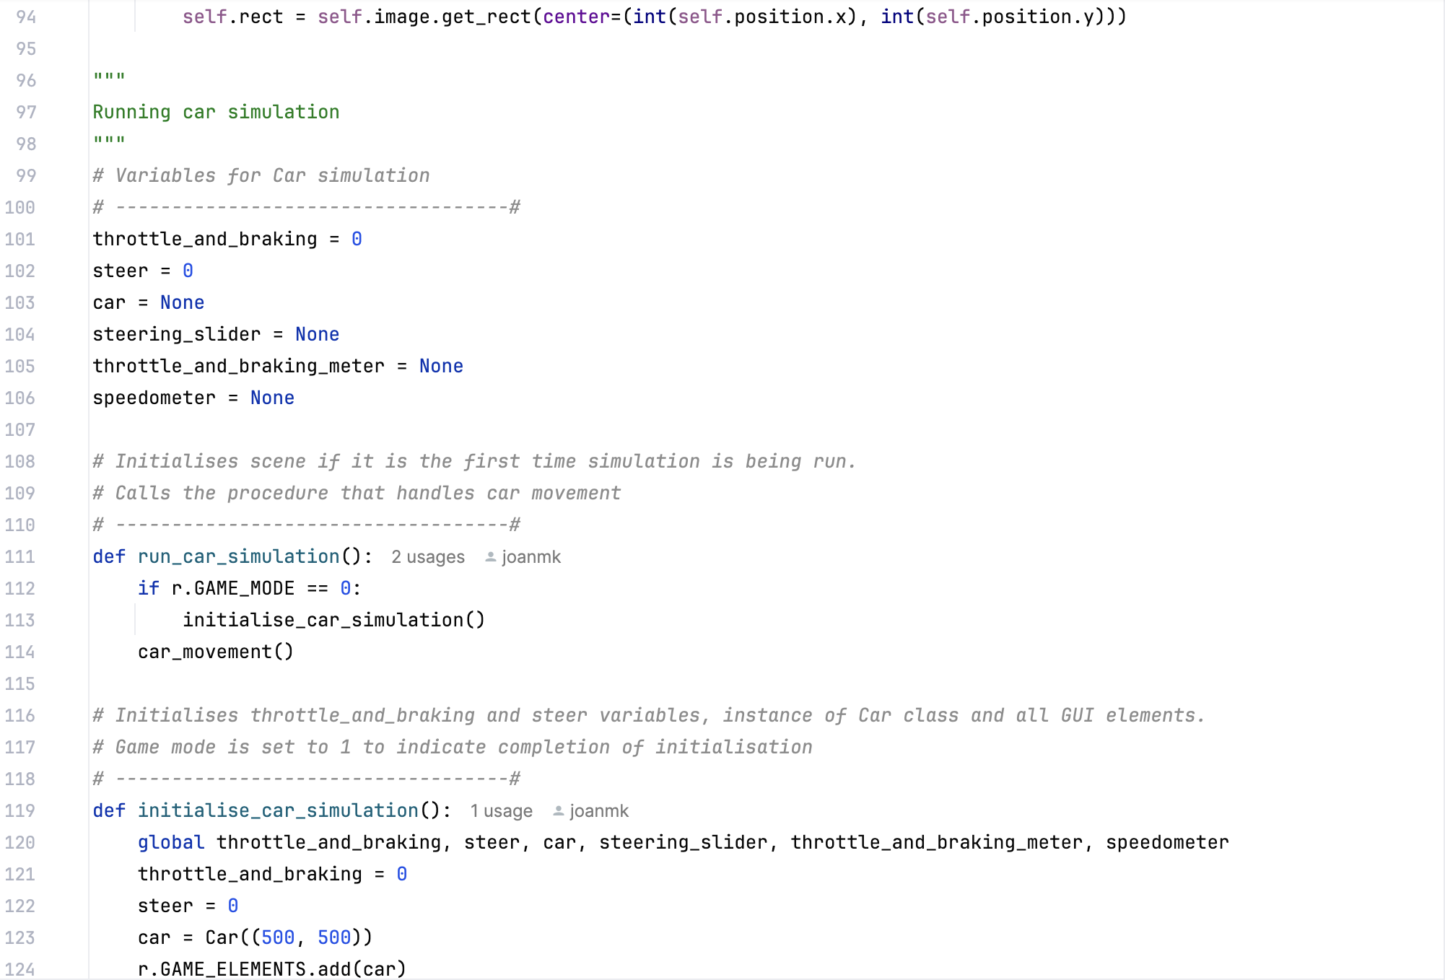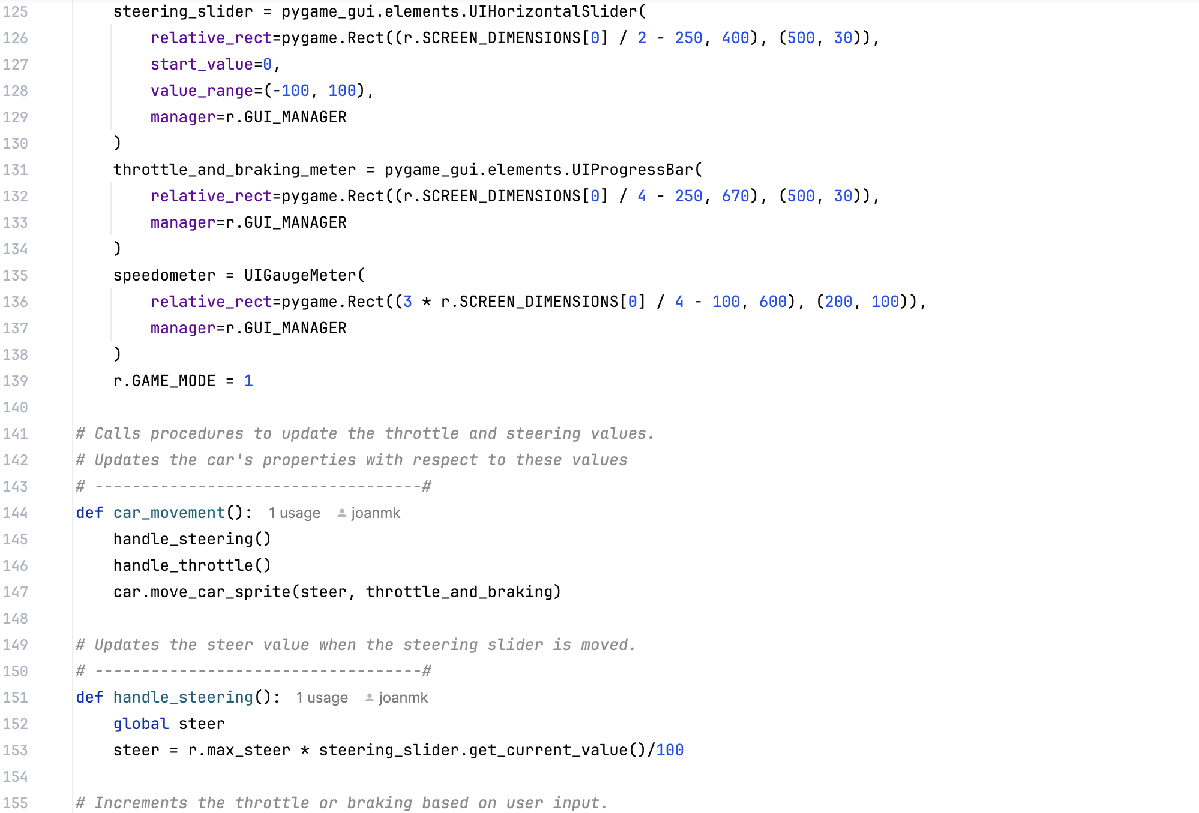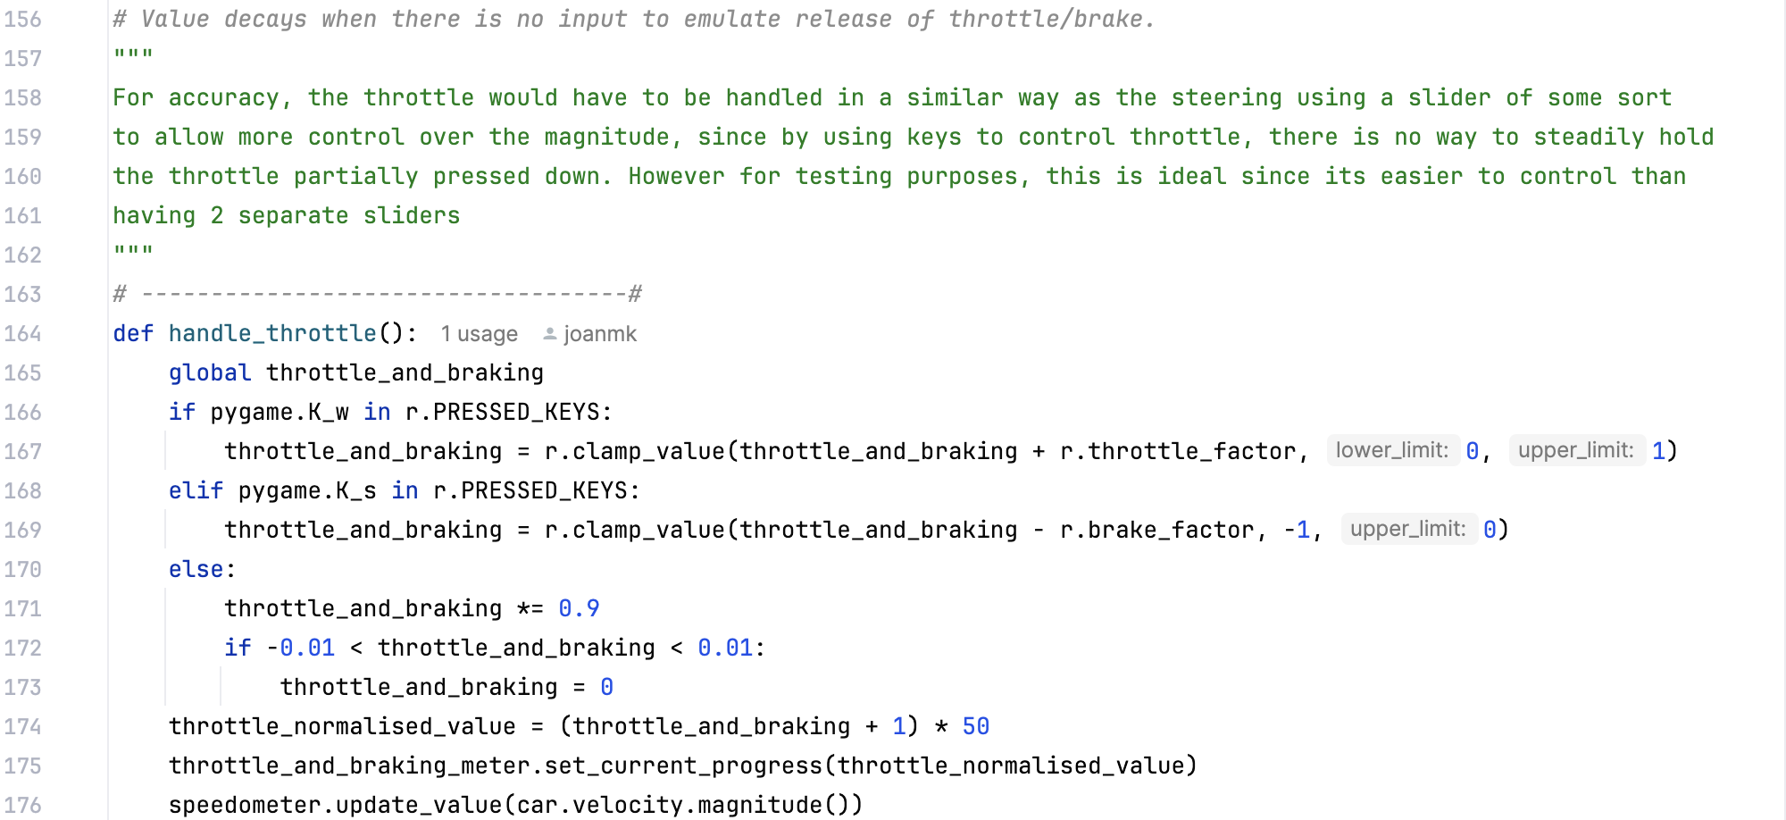
GUI_elements
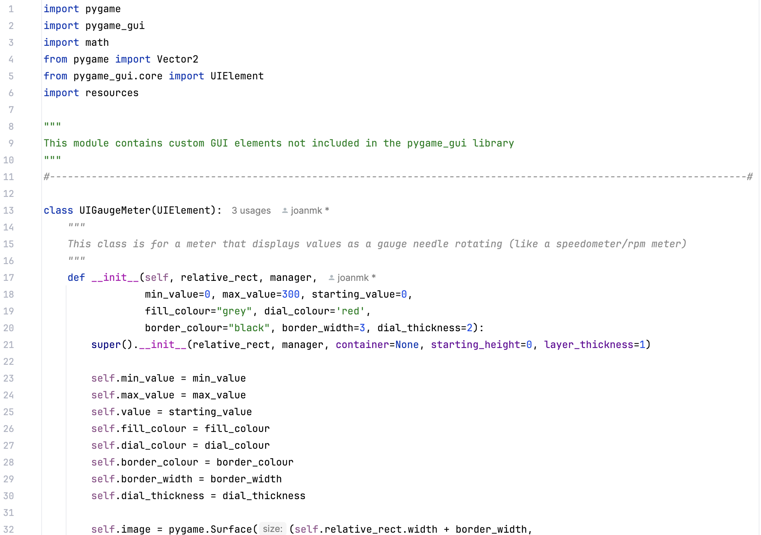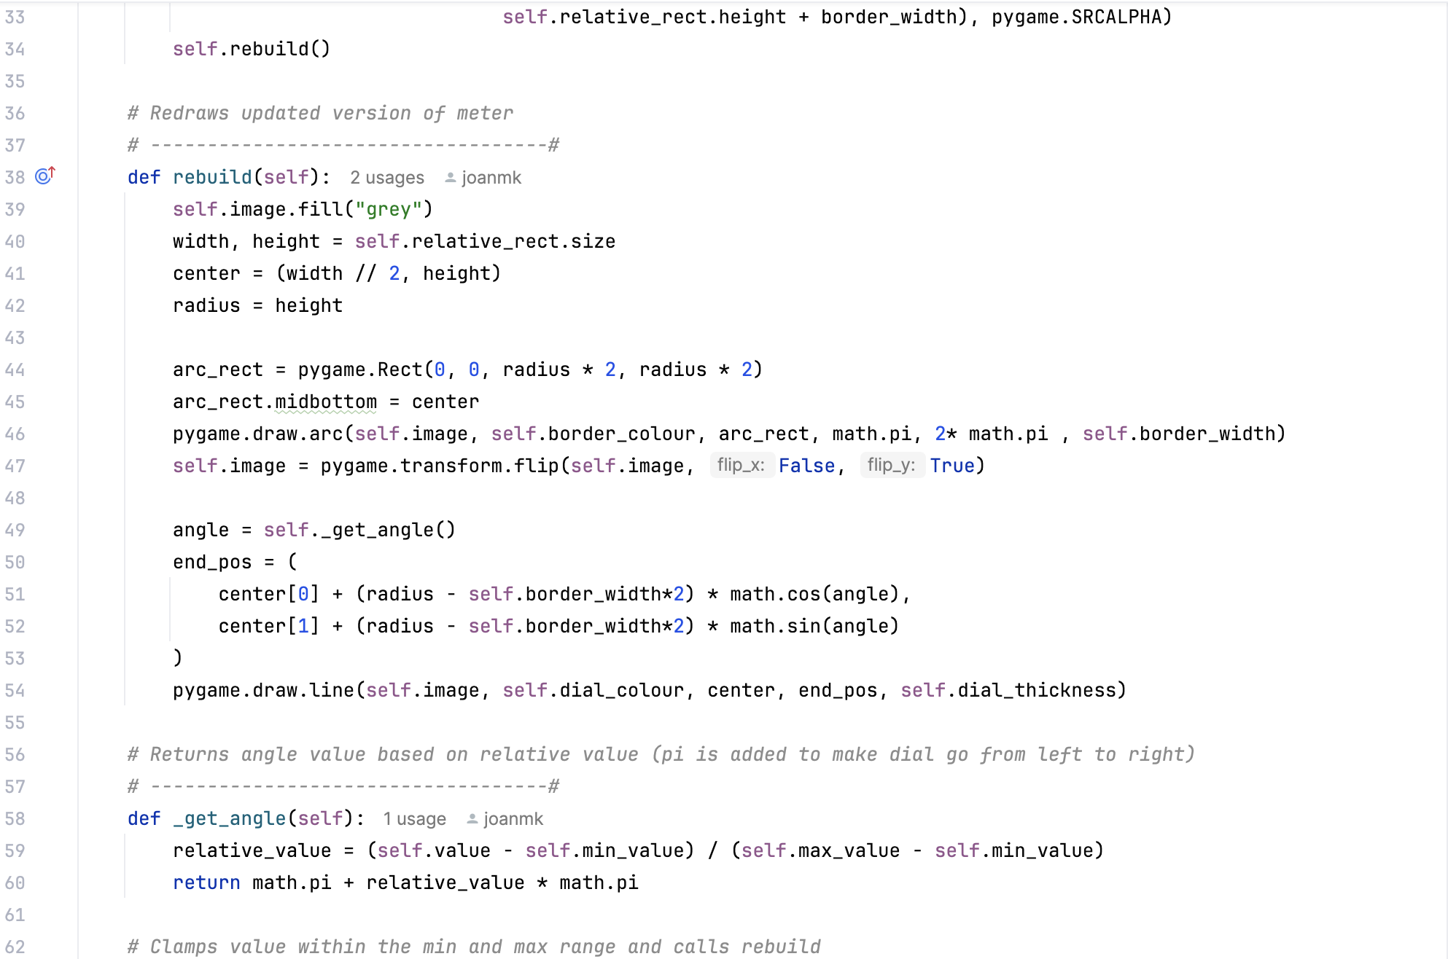
Resources
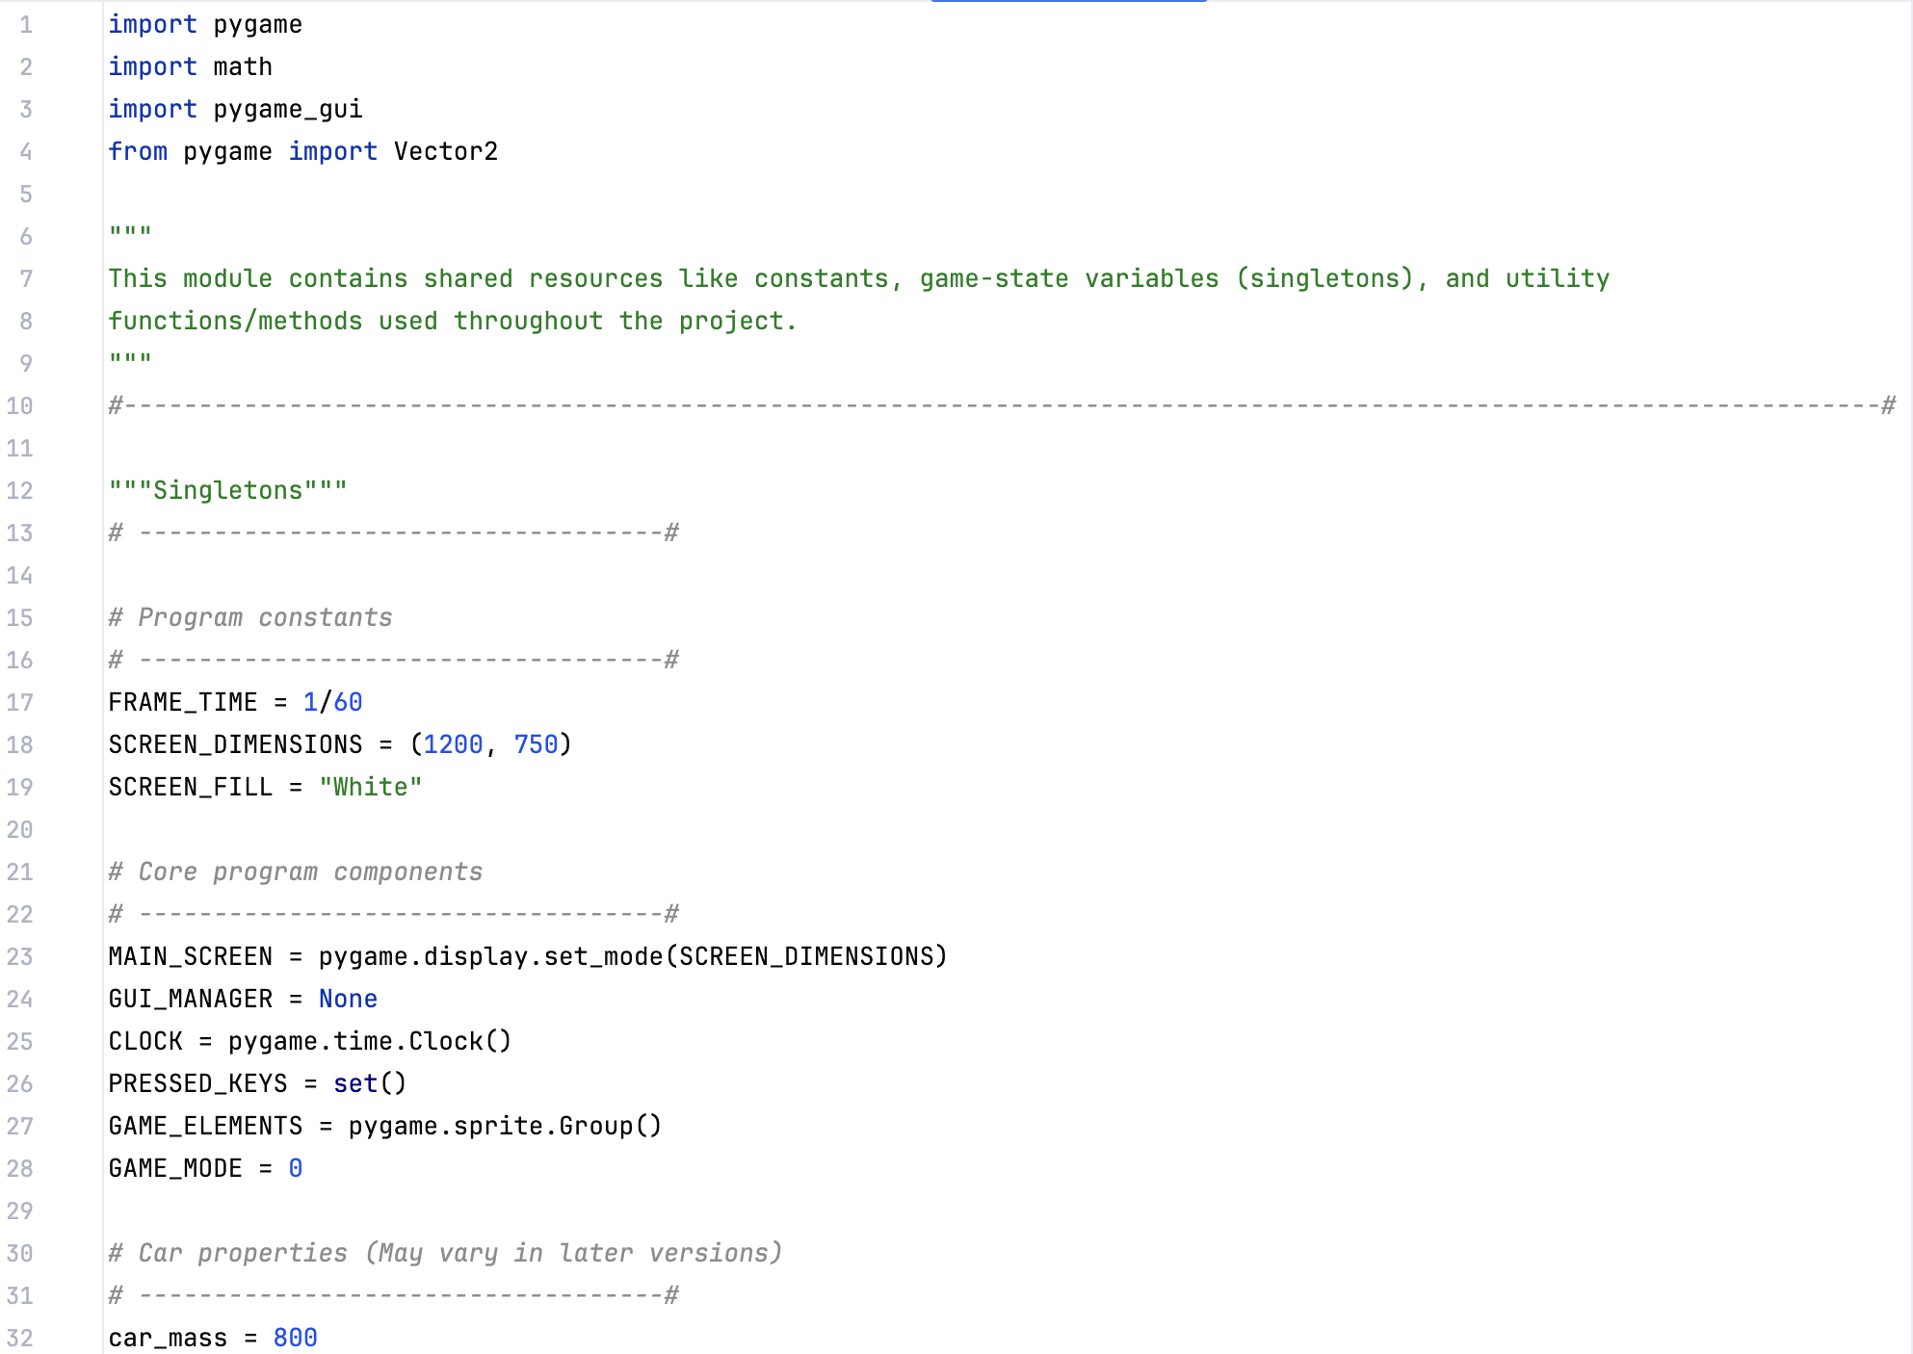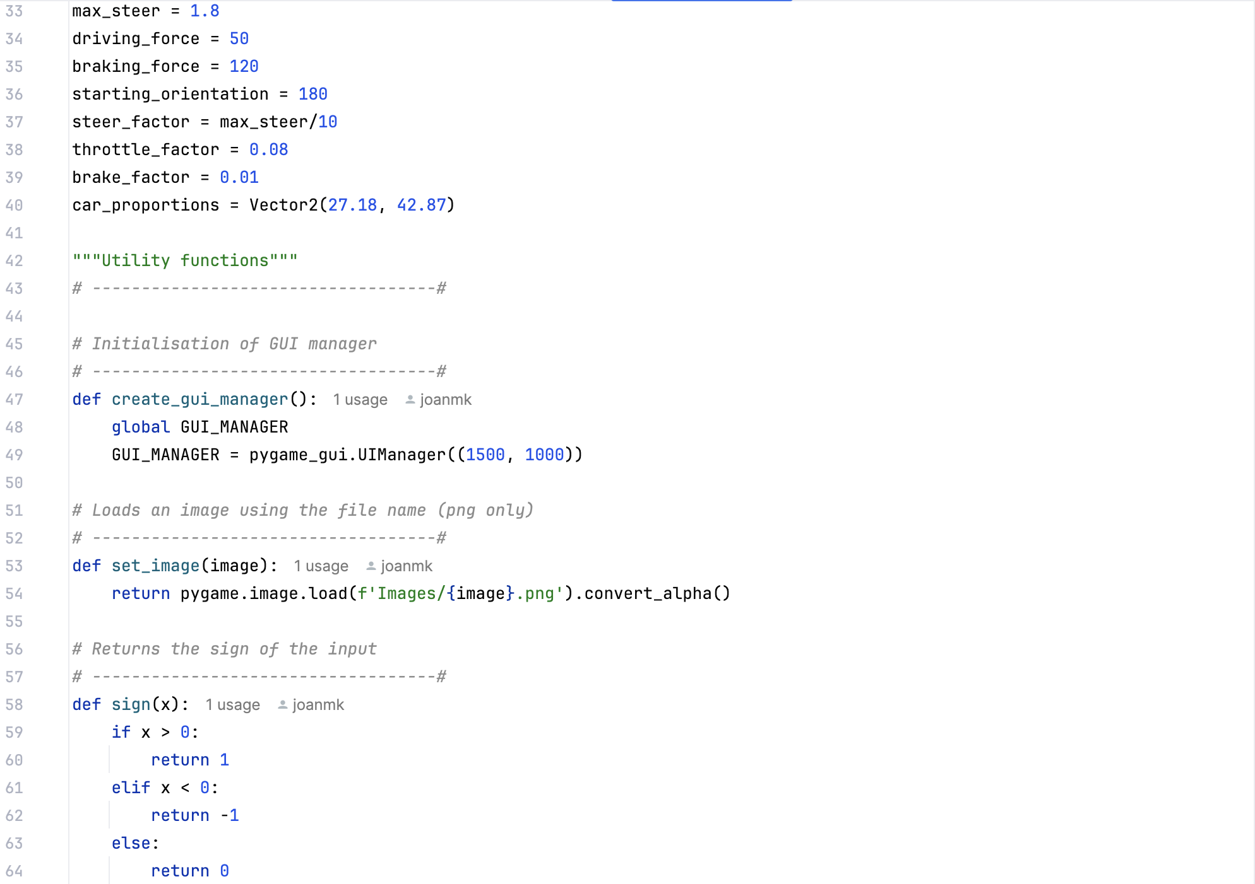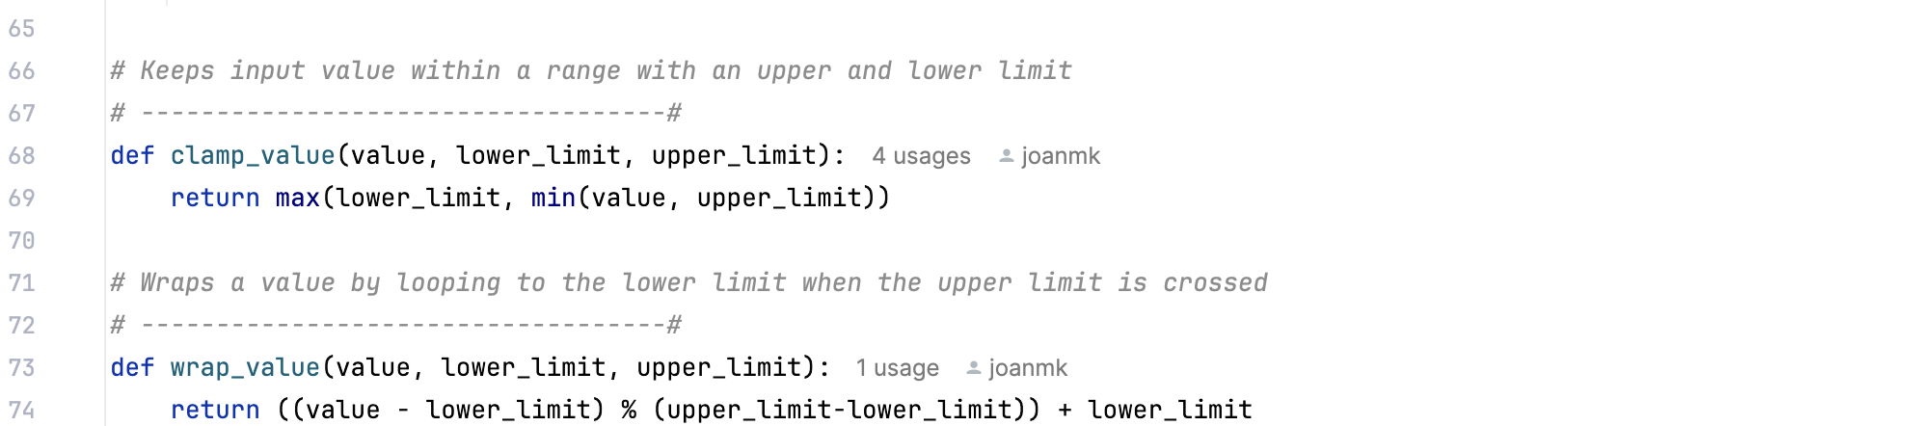

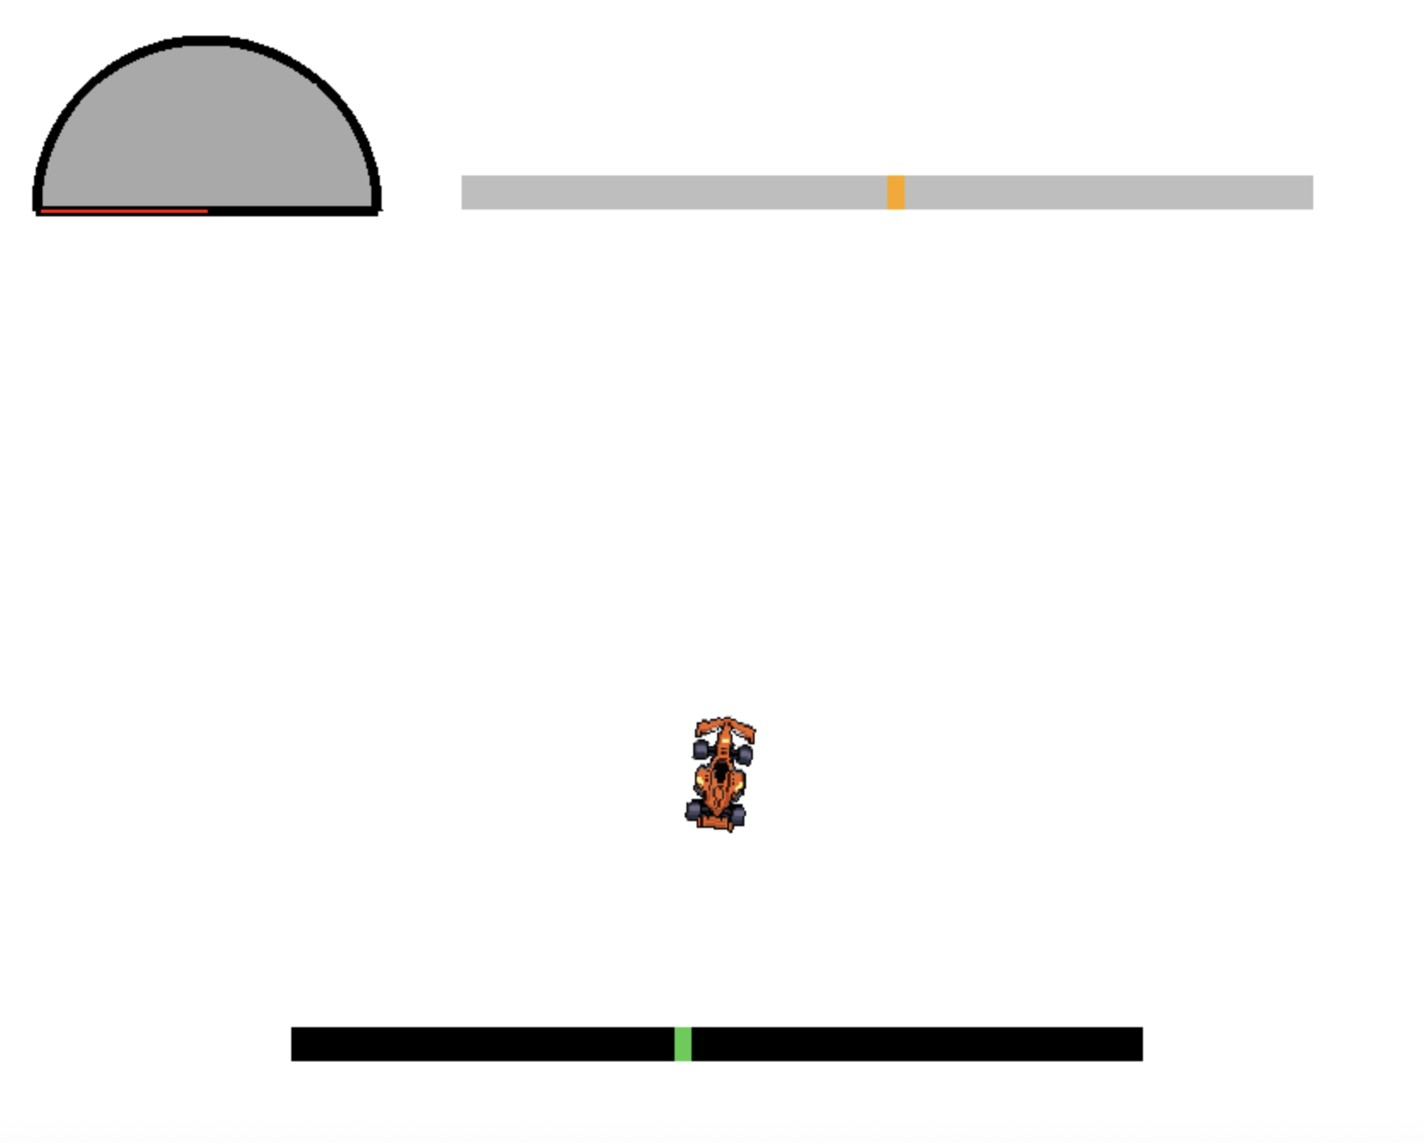

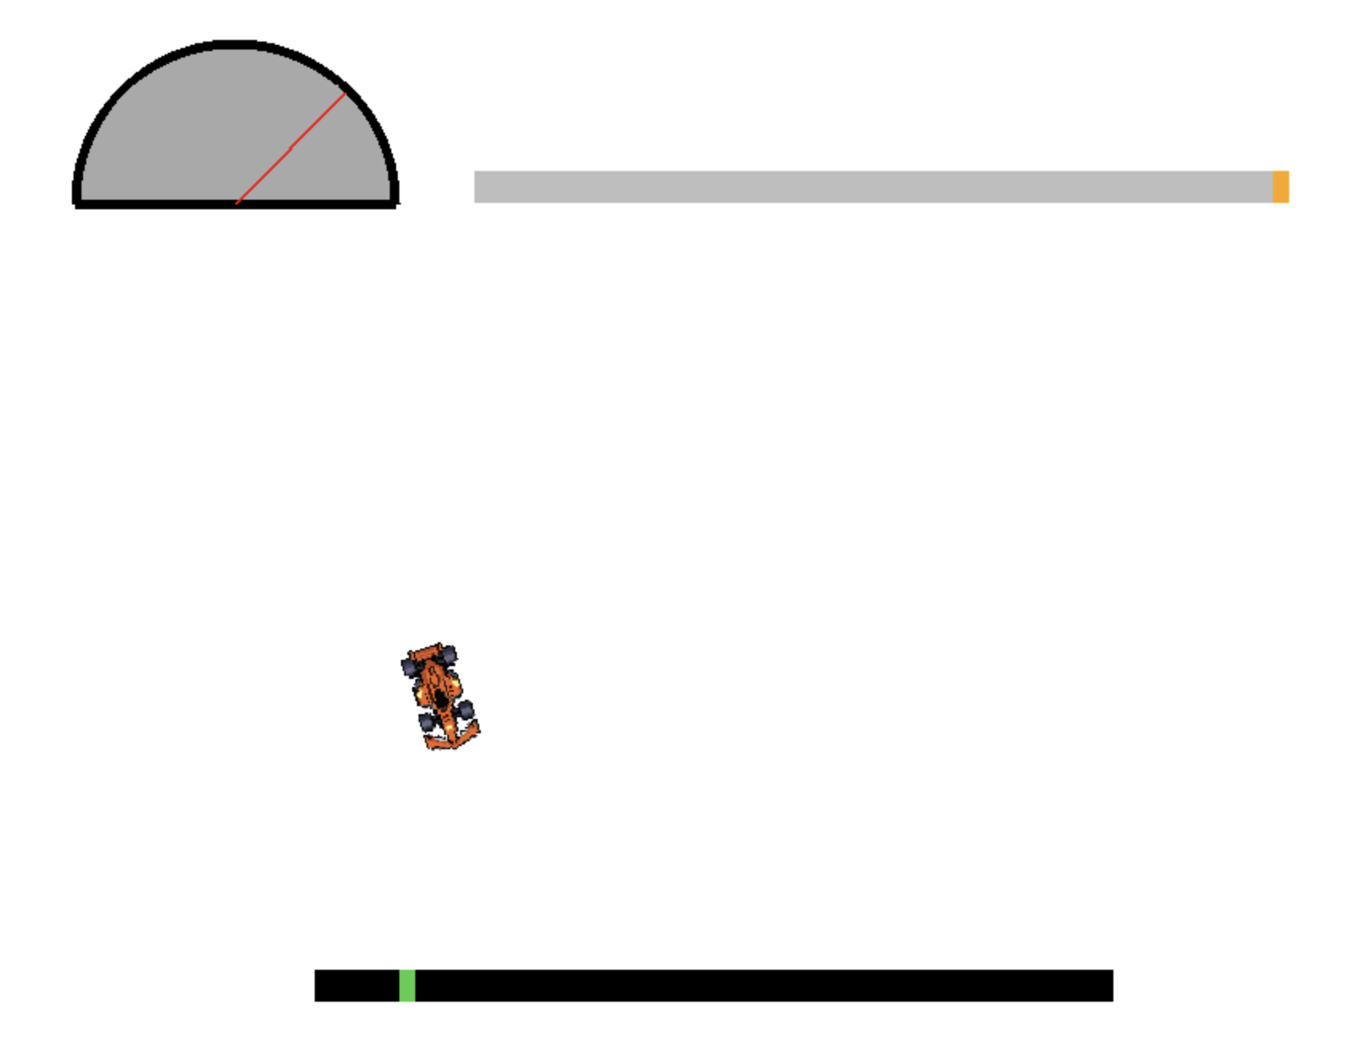

My initial idea to use the rectangle object of the sprite as the hitbox for collision detection, however when I tested it, the collision detection seemed to be highly inaccurate. This was because in python, rectangle objects are axis aligned, so a rotation in the car surface wouldn’t rotate its rectangle, instead it would change size. So, I would have to create a separate polygon object that outlines the car surface to effectively create a hitbox for collision detection.
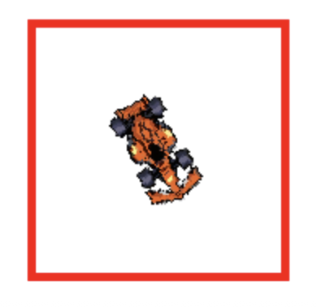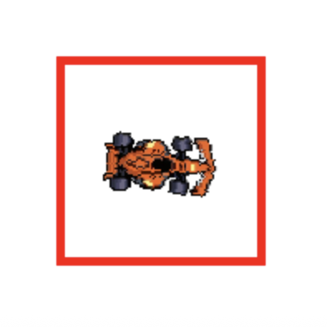

Spatial Hash Grid
To enable efficient ray casting and collision detection, I decided to store the track as a spatial hash grid data structure. This works by diving the 2D world into equally sized square cells and storing the references of each wall segment in the cell(s) they pass through. With my setup, most walls are present in one cell and cells can contain several wall segments. This allows for local collision detection rather than interating through every wall segment every cycle, since only wall segments in the cells that the object is in are checked. This makes the algorithm highly scalable and allows for many car simulations to be run simultaneously with minimal load.
I have implemented the grid using a dictionary (hash map) with the keys being integer coordinates of the cell and the paired value being the list of wall segment indices in that cell. Hashing is more memory efficient that just a large array since only cells containing segments are stored in memory. Using the wall segment indices also makes it so that only one copy of the wall segments array is stored in memory.
Using this data structure is suitable for my use case since the the ray casting algorithm I am using would be too computationally heavy for simultaneous simulation otherwise. Moreover, the track segments are static and therefore only need to be hashed once during creation, so reccursive methods like quadtree would actually lead to more load due to larger overheads. Spacial hash grid provides a suitable degree of optimisation.

Traversal Algorithm
To traverse the grid for hashing and querying, I have implemented the digital differential analyzer (DDA) algorithm. The algorithm works by calculating the differences in x and y coordinates between endpoints and determines the number of steps needed to move from the start cell to the end cell. It then incrementally advances along the line by incrementing along both the x and y axes to traverse the line. Increments are made along the axis that has a closer perpendicular cell boundary in the direction of the traversal from the current position. This method steps through every intersected grid cell in order exactly once, therefore allowing to accurately hash all relavent cells.
Pseudocode of algorithm:
DDA_traverse(segment, ):
start_point, end_point = segement
()

Crfeating an AI Model:
Artificial Intelligence (AI) refers to computer systems designed to perform tasks that typically require human intelligence, such as problem-solving, decision-making, pattern recognition, and content generation. Such systems undergo a training process by processing large amounts of data to generalise patterns and make predictions. This process of algorithmically training computer systems to solve problems is called machine learning (ML).
There are many different types of machine learning processes, each suited for a specific type of problem. The main types of learning are supervised, unsupervised and reinforcement learning. For my program to learn the fastest path around a track, the most suited form of ML is reinforcement learning (RL), since both supervised and unsupervised learning methods require a predefined dataset to learn, while RL learned from interacting with the testing environment . RL solves a particular kind of problem where decision making is sequential, and the goal is long term (which is a suitable description of my problem statement).
RL works by using some sort of “agent” to live in the given test environment. This agent must be capable of perceiving the “state” of the environment as a set of “features” and then execute an “action” in that state to bring it to the next state. Different actions bring different magnitudes of “rewards”, which are indications of how good the action taken was. The “policy” is the strategy that the agent uses to decide what action to take in each state. The goal of an RL algorithm is to learn the most optimal policy to maximise the total expected reward over the time that the model is run.

